Proactive Disclosure

# Environmental Scan

Entities that were reviewed:

* Agriculture and Agri-Food Canada
* Canada School of Public Service
* Canadian Food Inspection Agency
* Canadian Human Rights Commission
* Natural Resources Canada
* Information Commissioner of Canada
* Public Works and Government Services
* TeleFilm Canada
* Treasury Board Secretariat
* Veterans Affairs Canada

All of the reviewed departments presented information in the same way except for Disclosures of Wrongdoing. Only two departments presented this information CFIA and PWGSC, CFIA was structured and PWGSC was not.

# Entity Relationship Diagram

The ERD uses naming conventions in accordance with schema.org as recommended by the Web Interoperability Working Group, this can be seen with the Person, Government Organization and Postal Address tables, which represent Employee, Departments and Branches and Locations.

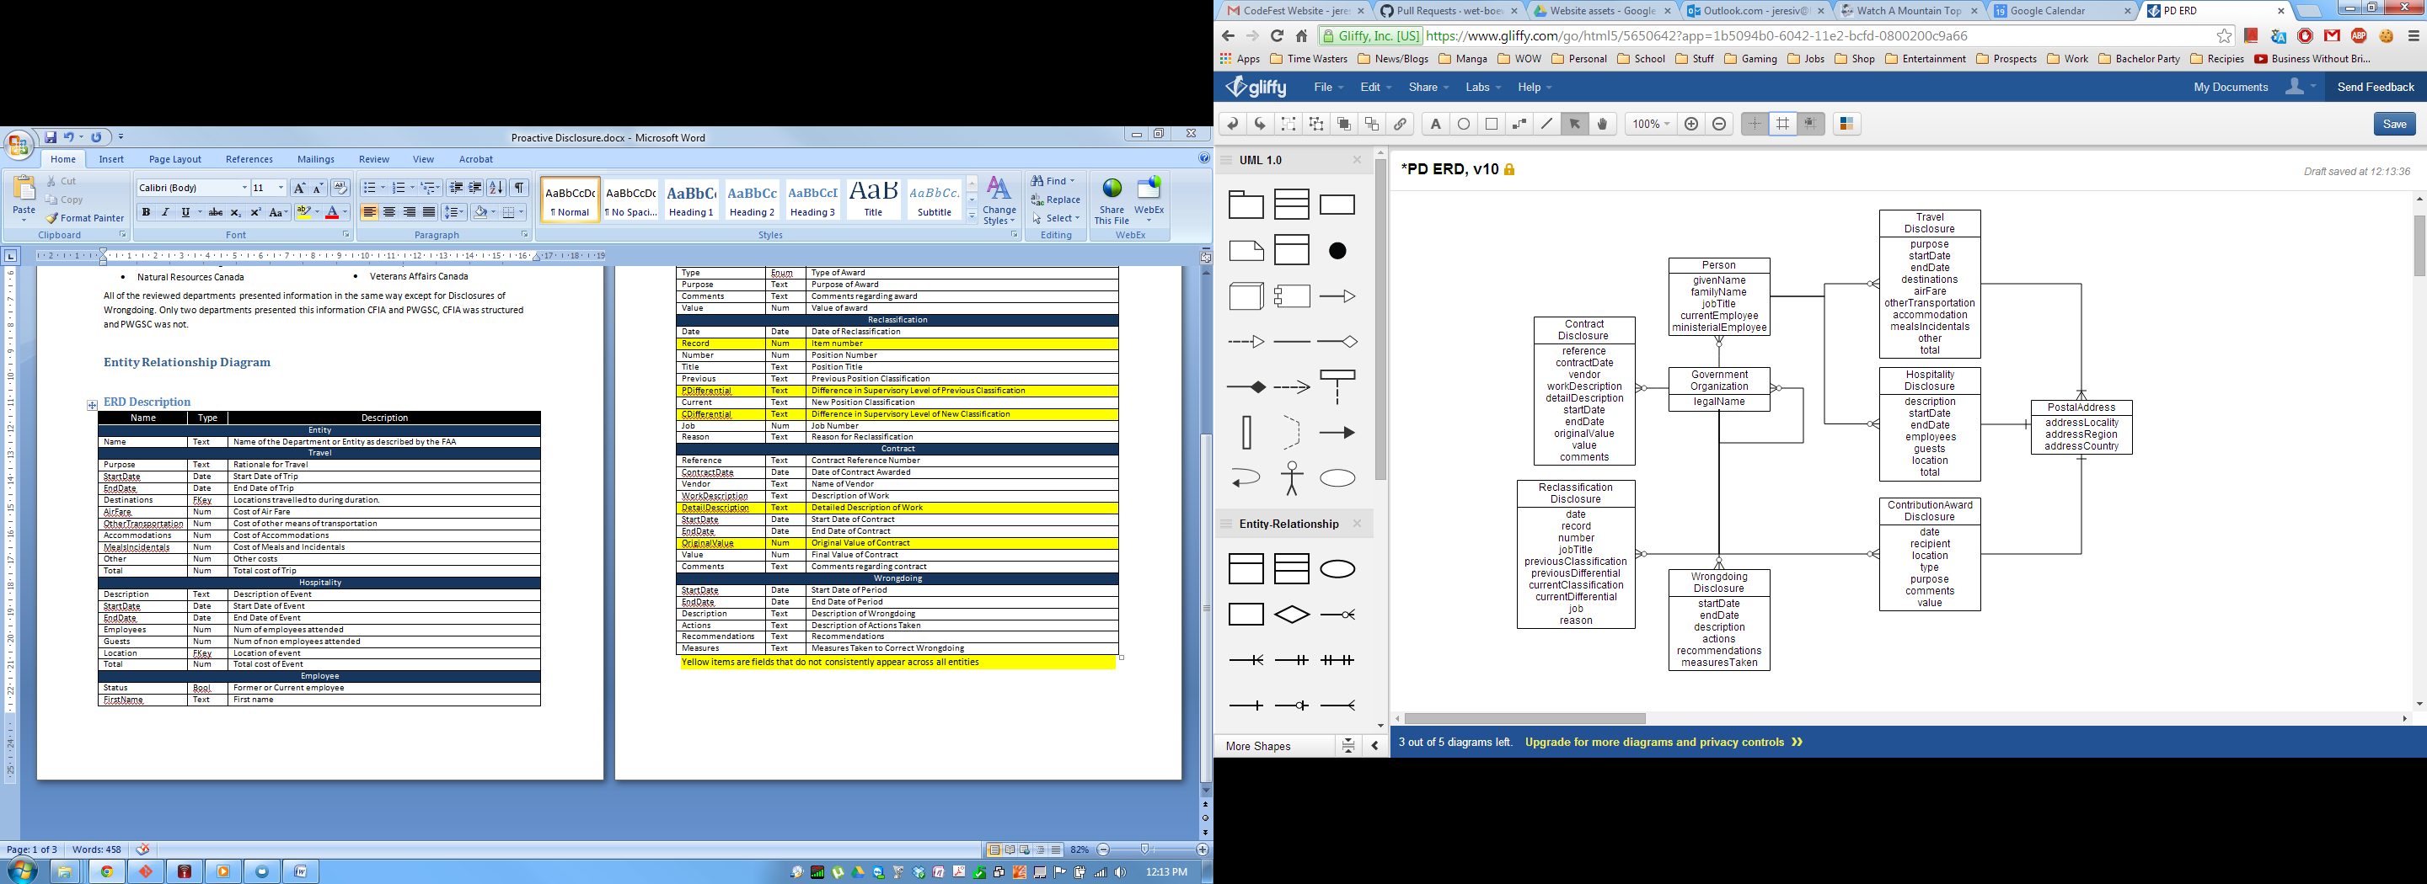

## ERD Description

|  |  |  |
| --- | --- | --- |
| Name | Type | Description |
| GovernmentOrganization | | |
| legalName | Text | Name of the Department or Entity as described by the FAA |
| ContractDisclosure | | |
| reference | Text | Contract Reference Number |
| contractDate | Date | Date of Contract Awarded |
| vendor | Text | Name of Vendor |
| workDescription | Text | Description of Work |
| detailDescription | Text | Detailed Description of Work |
| startDate | Date | Start Date of Contract |
| endDate | Date | End Date of Contract |
| originalValue | Num | Original Value of Contract |
| value | Num | Final Value of Contract |
| comments | Text | Comments regarding contract |
| Wrongdoing | | |
| startDate | Date | Start Date of Period |
| endDate | Date | End Date of Period |
| description | Text | Description of Wrongdoing |
| actions | Text | Description of Actions Taken |
| recommendations | Text | Recommendations |
| measuresTaken | Text | Measures Taken to Correct Wrongdoing |
| ReclassificationDisclosure | | |
| date | Date | Date of Reclassification |
| record | Num | Item number |
| number | Num | Position Number |
| title | Text | Position Title |
| previousClassification | Text | Previous Position Classification |
| previousDifferential | Text | Difference in Supervisory Level of Previous Classification |
| currentClassification | Text | New Position Classification |
| currentDifferential | Text | Difference in Supervisory Level of New Classification |
| jobNumber | Num | Job Number |
| reason | Text | Reason for Reclassification |
| ContributionAwardDisclosure | | |
| date | Date | Date of Award |
| recipient | Text | Name of Recipient |
| location | FKey | Location involved |
| type | Enum | Type of Award |
| purpose | Text | Purpose of Award |
| comments | Text | Comments regarding award |
| value | Num | Value of award |
| Person | | |
| givenName | Text | First name |
| familyName | Text | Last name |
| jobTitle | Text | Position Title |
| currentEmployee | Bool | Former or Current employee |
| ministerialEmployee | Bool | Senior or Minister staff employee |
| PostalAddress | | |
| addressLocality | Text | Name of City or Locality |
| addressRegion | Text | Name of Province or State or Region |
| addressCountry | Text | Name of Country |
| TravelDisclosure | | |
| purpose | Text | Rationale for Travel |
| startDate | Date | Start Date of Trip |
| endDate | Date | End Date of Trip |
| destinations | FKey | Locations visited during duration of travel. |
| airFare | Num | Cost of Air Fare |
| otherTransportation | Num | Cost of other means of transportation |
| accommodations | Num | Cost of Accommodations |
| mealsIncidentals | Num | Cost of Meals and Incidentals |
| other | Num | Other costs |
| total | Num | Total cost of Trip |
| HospitalityDisclosure | | |
| description | Text | Description of Event |
| startDate | Date | Start Date of Event |
| endDate | Date | End Date of Event |
| employees | Num | Num of employees attended |
| guests | Num | Num of non employees attended |
| location | FKey | Location of event |
| total | Num | Total cost of Event |